Preparation of Abstracts in One-Page Format for the RAAD 2009 Book of Abstracts
Alfred Hofmann1, Ingrid Beyer¹, and Angelika Bernauer-Budiman2
1 Springer-Verlag, Computer Science Editorial III, Postfach 10 52 80,
69042 Heidelberg, Germany
{Hofmann, Beyer}@Springer.de
2 Springer-Verlag, Computer Science Production, Postfach 10 52 80,
69042 Heidelberg, Germany
Bernauer@Springer.de

The abstract should summarize the contents of the paper and should contain at least 70 and at most 180 words. The page style is in accordance with Springer-Verlag lncs format.
The printing area is 122 mm x 193 mm. The text should be justified to occupy the full line width, so that the right margin is not ragged, with words hyphenated as appropriate. Please fill pages so that the length of the text is no less than 180 mm. Use 10-point type for the name(s) of the author(s) and 9-point type for the address(es). For the abstract text, please use 10-point type and single-line spacing. We recommend using Computer Modern Roman (CM) fonts, Times, or one of the similar typefaces.
Authors are encouraged to add one or two figures to better present the thematics. Please add the figure caption and position it under the figure. Center the caption between the margins and set it in 9-point type (Fig. 1 shows an example). The distance between text and figure should be about 8 mm, the distance between figure and caption about 5 mm.
Please submit the abstract (together with full paper) in PDF format electronically to the conference e-mail address: raad09@cimr.pub.ro.
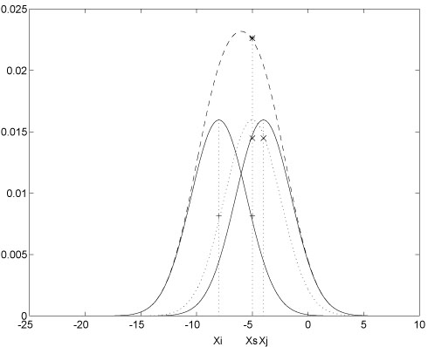
Fig. 1. This is a sample figure caption. The last sentence of a figure caption should generally end without a period

